SANGAMESHWAR COLLEGE (AUTONOMOUS), SOLAPUR
DEPARTMENT OF MARATHI
MINUTES OF THE 3rd BOARD OF STUDIES (Marathi)

A meeting of Board of Studies in Marathi, Department of Marathi, Sangameshwar College(Autonomous), Solapur was held on Friday May 24, 2021 at 4.00 pm.
The said meeting was arranged online on Google Meet platform.
Link of Google Meet Meeting:
https://meet.google.com/dip-ufhs-xzd
Agenda of the meeting
1) Confirmation of the minutes of the previous meeting.
2) Discussion and approval of B. A. II Year syllabus.
3) Any other item with the permission of chair.
Following members were present for the meeting:
Attendees:
1. Dr. Suhas Pujari, Professor and HoD, Chairman of BoS, Marathi
2. Dr. Rajshekhr Shinde, Subject Expert, D.B.F. Dayanand College of Arts and Science, Solapur,
VC Nominee, PAHSU, Solapur
3. Prof. Randhir Shinde, Subject Expert, Professor and HoD, Shivaji University, Kolhapur
4. Prof. Keshav Sakharam Deshmukh, Subject Expert, Professor and HoD, S.R.T.M. University,
Nanded
5. Mr. Madhav Deshpande, Industry expert, Solapur
6. Dr. Devidas Gurav, Alumni, Sangameshwar College, Solapur,
7. Prof. Mahadeo Deshmukh, Sangameshwar College, Solapur
8. Dr. Sariputra Tupere, Sangameshwar College, Solapur

Dr. S.G.Pujari, Professor and Head of the Department, opened the meeting with a welcome address and introduced each member of the board. The chairman began the presentation on the previous meeting's minutes, which were unanimously approved by all BoS members.
During the meeting of Board of Studies, the following points were discussed.
1. B.A. II Course Structure and syllabus:
The BoS Chairman began his presentation by outlining the units covered in the B.A. Part II Programme.
2. The Board of Studies -Marathi of Punyashlok Ahilyadevi Holkar Solapur University had decided to include Nirmalkumar Phadkule's collection of fine prose 'Hirvya Vata' in the syllabus of B.A.II, Optional Marathi. The BoS of Marathi, Sangameshwar College (Autonomous), has also decided to include Nirmalkumar Phadkule's collection of fine prose 'Hirvaya Vata' in the syllabus of B.A.II, Optional Marathi. The syllabus was further discussed and finalized by the members of BoS.
3. Syllabus of IDS - History of Social Reforms in Maharashtra (HSRM) Part 1 & 2 was also unanimously approved by all BoS members.
4. 20 to 25 % of the syllabus of the parent university has been changed to the syllabus of the autonomous college
The syllabus of the B.A.II is approved and recommended to the Academic Council for approval and to implementation of the syllabus from the Academic Year 2021-22. Finally, the meeting was concluded with the permission of chair by extending Vote of Thanks by Dr. S.A.Tupere

Prof. Suhas Pujari
BOS, MARATHI Chairman
Dr. N. N. Tantak, BOS VC Nominee PAH
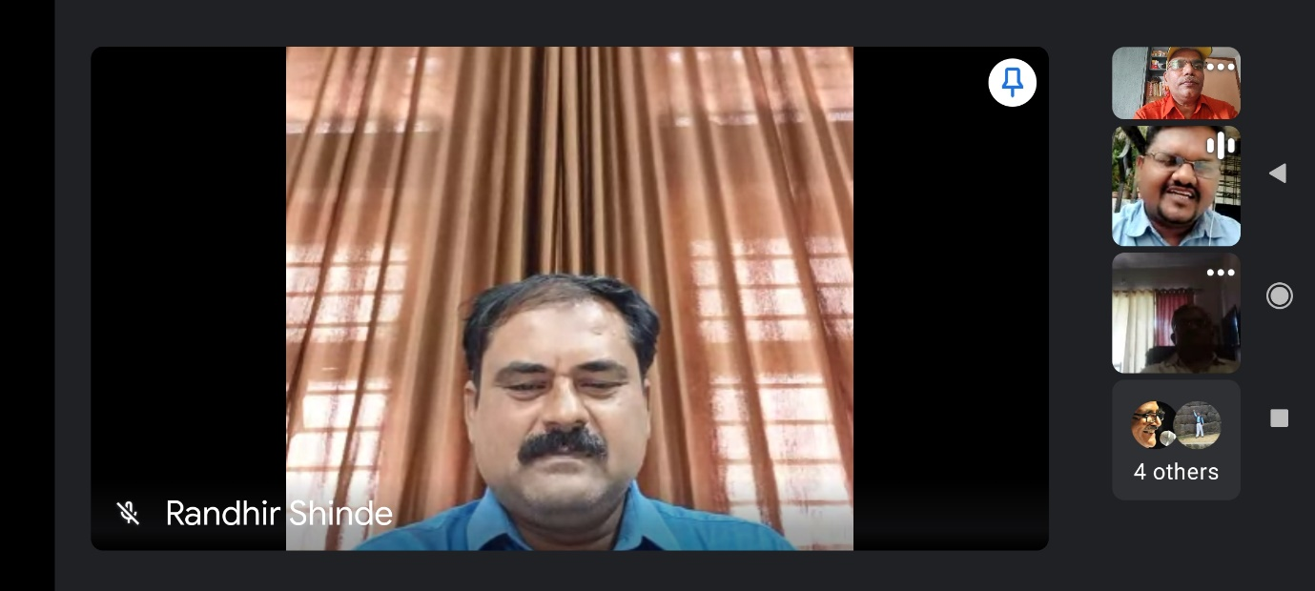
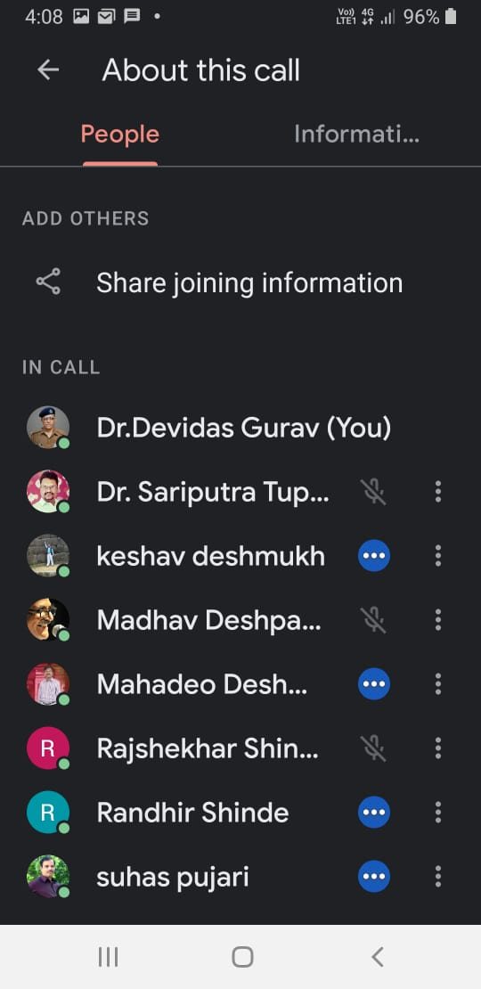SU

