SANGAMESHWAR COLLEGE (AUTONOMOUS), SOLAPUR
DEPARTMENT OF MARATHI
MINUTES OF THE 5thMEETING OF BOARD OF STUDIES (Marathi)

A meeting of Board of Studies in Marathi, Department of Marathi, Sangameshwar College(Autonomous), Solapur was held on Friday, May 13, 2022 at 12.15 pm.
The said meeting was arranged online on ZOOM Meeting platform.
Link of ZOOM Meeting:
https://us02web.zoom.us/j/82075904098?pwd=b0dmRGg4MFVmYW9QODVQSnR4dHJ0UT09
Agenda of the meeting
1) Confirmation of the minutes of the previous meeting.
2) Discussion and approval of B. A. III Year syllabus.
3) Any other item with the permission of chair.

Following members were present for the meeting:
Attendees:
1. Dr.Suhas Pujari, Professor and HoD, Chairman of BoS, Marathi
2. Dr.Rajshekhr Shinde, Subject Expert, D.B.F. Dayanand College of Arts and Science, Solapur,
VC Nominee, PAHSU, Solapur
3. Prof.Randhir Shinde, Subject Expert, Professor and HoD, Shivaji University, Kolhapur
4. Prof.Keshav Sakharam Deshmukh, Subject Expert, Professor and HoD, S.R.T.M. University,
Nanded
5. Mr.Madhav Deshpande, Industry expert, Solapur
6. Dr.Devidas Gurav, Alumni, Sangameshwar College, Solapur,
7. Prof.Mahadeo Deshmukh, Sangameshwar College, Solapur
8. Dr.Sariputra Tupere, Sangameshwar College, Solapur

Dr. S.G.Pujari, Professor and Head of the Department, opened the meeting with a welcome address. The chairman began the presentation on the previous meeting's minutes, which were unanimously approved by all BoS members.
During the meeting of Board of Studies, the following points were discussed.
1. B.A. III Course Structure and syllabus:
The BoS Chairman began his presentation by outlining the units covered in the B.A. Part III Programme.
2. Syllabus of B.A. Part 3, Marathi, Sem. V and VI, Paper no. VII to XVI and as well as Skill Enhancement Course revised syllabus was placed before the BoS for review. After the discussion particularly the paper no. X and XV were accepted and the amendments were unanimously approved. The syllabus was finalized by the members of BoS.
3. Syllabus of BA Part 2, Civil Services (Sem. III & IV) of Marathi subject were prepared with the deliberation and consent of all the members of the BoS and it was unanimously approved
4. 20 to 25 % of the syllabus of the parent university has been changed to the syllabus of the autonomous college
The syllabus of the B.A.III is approved and recommended to the Academic Council for approval and to implementation of the syllabus from the Academic Year 2022-23. Finally, the meeting was concluded with the permission of chair by extending Vote of Thanks by Dr. S.A.Tupere

Prof. Suhas Pujari
Chairman
BOS, MARATHI

VC Nominee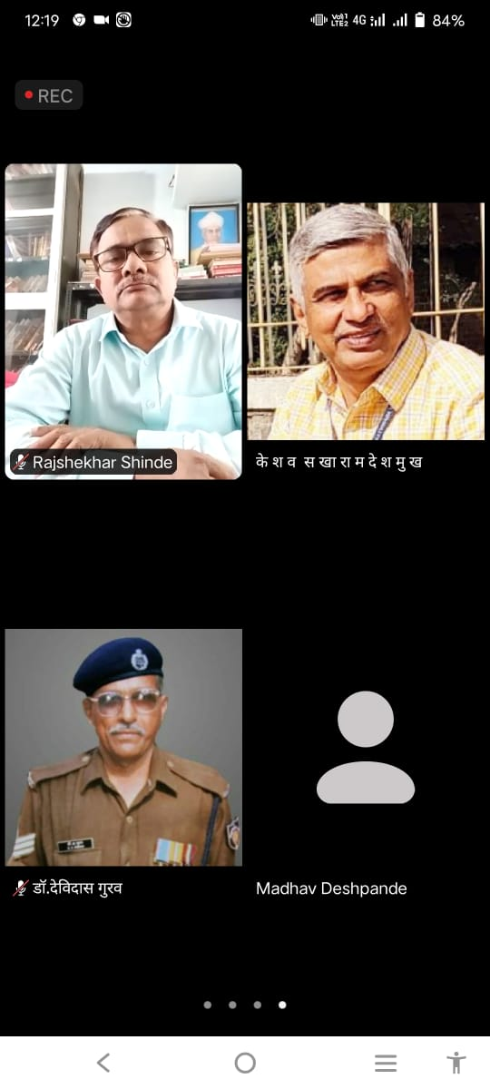 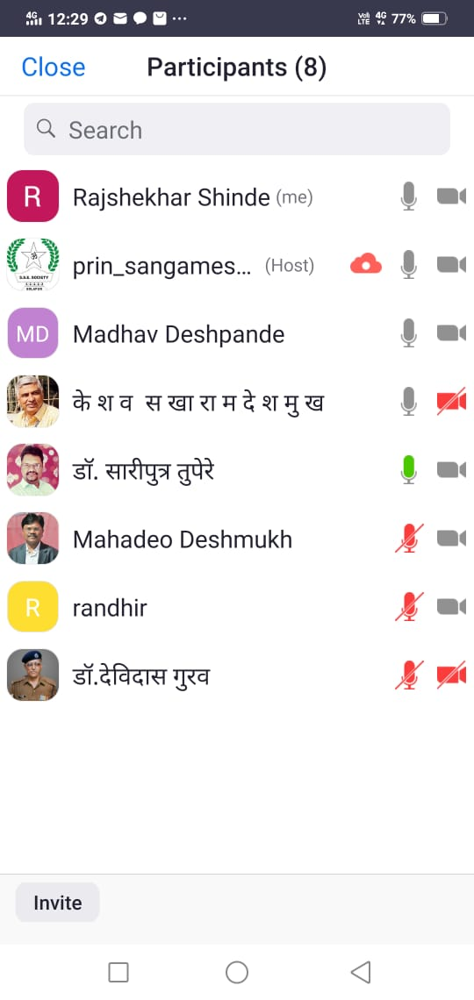 PAHSU

