**SANGAMESHWAR COLLEGE (AUTONOMOUS), SOLAPUR**

**DEPARTMENT OF BOTANY**

**MINUTES OF THE II BOS**

A meeting of Board of Studies in Botany Sangameshwar College, Solapur (Autonomous) was held on Friday March 20, 2021 at 11.00 am

The said meeting was arranged online on Zoom platform.

**Link of Zoom Meeting**:

Suhas Dahitnekar is inviting you to a scheduled Zoom meeting.

Topic: Sangameshwar college Solapur Botany BOS meeting

Time: Mar 20, 2021 12:30 PM India

Join Zoom Meeting

https://us04web.zoom.us/j/74255052763?pwd=QW90b2I4b3pSUXZ3ZU13amU3Rmh3QT09

Meeting ID: 742 5505 2763

Passcode: 2RfaLP

**Agenda of the meeting**

1) Confirmation of the minutes of the previous meeting

2) Discussion of second year draft syllabus

3) Any other item with the permission of chair

Following members were present for the meeting:

**Attendees:**

1. Dr. Suhas M.Dahitnekar BOS chairman sangameshwar college

Solapur

|  |  |
| --- | --- |
| 2 Dr.A.M.Chavan | Dept of Botany Dr.B.A.M.U Aurangabad |

|  |  |
| --- | --- |
| 3 Dr.M.M.Sardesai | Dept of Botany S.P.Pune uni.Pune |

4. Dr.M.N.Jagtap D.B.F.Dayanand college Solapur

5. Dr.S.T.Bandewar Rajarshi Shahu A.C.and Science College Pathari

6. Shri Yamul N.B. Institute of Science Nagpur

Dr.S.D Gothe vice principal of science wing of Sangameshwar college Solapur introduces the college and delivered the wel come note

Dr.S.M.Dahitnekar chairman of BOS introduced all members and began the presentation with previous meeting minutes which were approved by all BOS members.

**During the Board of Studies meeting, the following points were discussed.**

1. Discussion of second year draft syllabus

All members discussed about all papers and suggested Dr.A.M.chavan suggested to add local need based topics in syllabus.

Dr.S.T.Bandewar representative of industry suggested that include topics which are based on plant ecology to get the maximum production.

1. Any other item with the permission of chair

No any issues were raised so meeting was ended with extending vote of thanks by Dr.S.M.Dahitnekar.

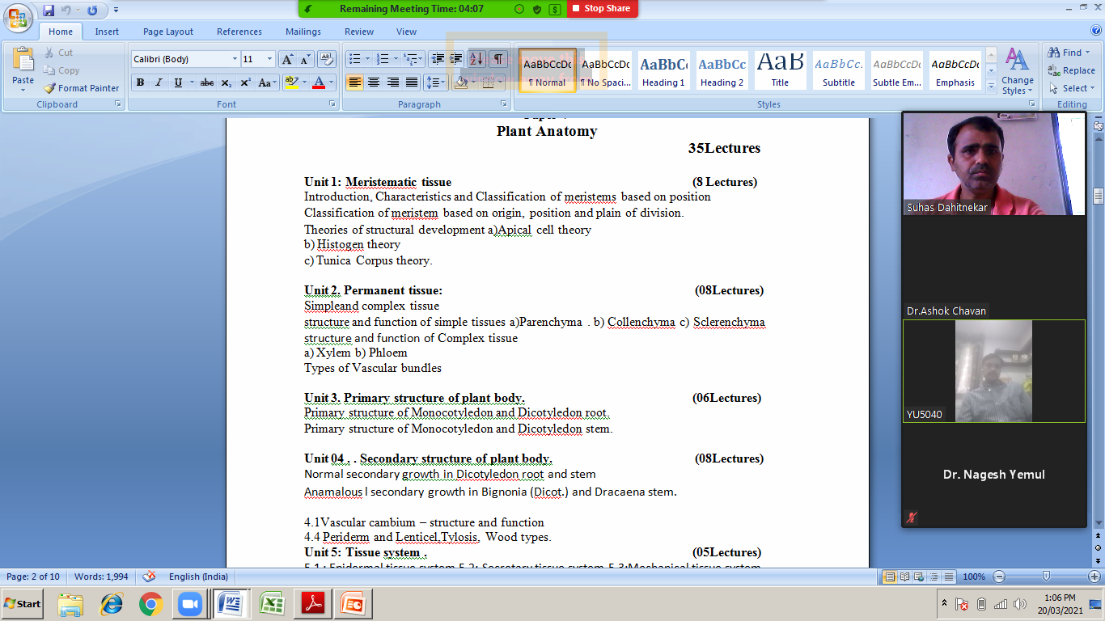

**BOS Chairman**