**SANGAMESHWAR COLLEGE (AUTONOMOUS), SOLAPUR**

**DEPARTMENT OF CHEMISTRY**

**Minutes of the2nd BOS (Chemistry) Meeting**

A meeting of Board of Studies in Chemistry of Sangameshwar College, Solapur (Autonomous) was held on 19th March 2021 at 12.30 p.m. The said meeting was arranged on Zoom platform. The link for the online meeting was as under:

* (<https://us02web.zoom.us/j/88167735571/pwd=cUZHTk9IVGZYaUVpQ1gzOFhQcDJLUT09>

Meeting ID: 88167735571 Passcode: chemistry

**Agenda of the meeting:**

1. To confirm the minutes of the previous meeting
2. Discussion of second year draft syllabus
3. Discussion on implementation of Skill Based Certificate course.
4. Any other subject with the permission of chair

Following members were present for the meeting:

|  |  |  |
| --- | --- | --- |
| **Sr. No.** | **Name of the Member** | **Designation** |
| 1 | Dr. U. M. Mandle | Chairman |
| 2 | Dr.U.B. Chanshetti | (V.C.Nominee from the Parent University) |
| 3 | Dr. G. S. Gokavi | Subject Expert outside the Parent University |
| 4 | Dr. A. R. Patil | Subject Expert outside the Parent University |
| 5 | Dr. Ravi Vibhute | Industry expert |
| 6 | Dr. S. H. Gaikwad | PG Meritorious Alumnus |
| 7 | Ms. K. D. Gaikwad | Member |
| 8 | Dr. Ms. A. V. Diwate | Member |
| 9 | Mr. S. D. Shaikh | Member |
| 10 | Dr. D. S. Mhamane | Member |
| 11 | Dr. P. B. Gorepatil | Member |

**All the members were present for the BOS meeting.**

**Discussion as per Agenda:**

1. To confirm the minutes of 1st meeting of BOS B.Sc. I held on 2nd July 2020 at 11.0 AM.

The Board considered and confirmed the minutes of the 1st meeting held on 2 July 2020 at 11.0 AM.

1. Discussion made on skill course and approved the skill course.

After an in-depth discussion, the committeemembers unanimously approved the syllabus.

Finally, with the chair's permission, the meeting ended with vote of thanks by Mr. S. D. Shaikh.

**Screenshot of Online Meeting (Attendance)**

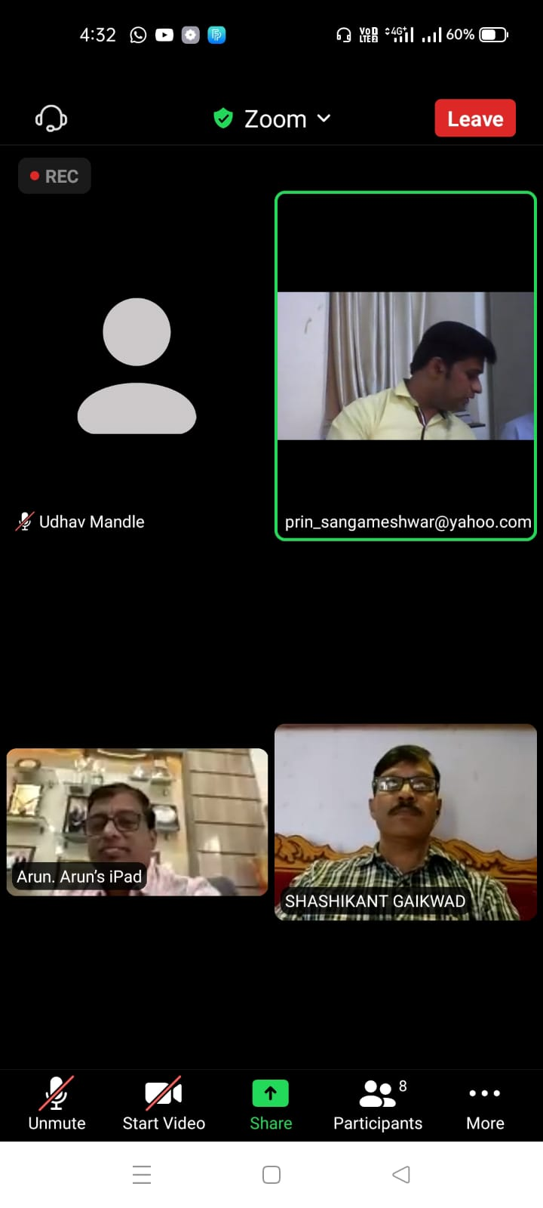

Chairman

Board of Studies Chemistry

Dr. U.M Mandle