**SANGAMESHWAR COLLEGE (AUTONOMOUS), SOLAPUR**

**DEPARTMENT OF CHEMISTRY**

**Minutes of the 3rd BOS (Chemistry) Meeting**

A meeting of Board of Studies in Chemistry of Sangameshwar College, Solapur (Autonomous) was held on 28th May 2021 at 12.30 p.m. The said meeting was arranged on Zoom platform. The link for the online meeting was as under:

* <https://zoom.us/j/92487920871?pwd=L2Z2QlVXYUlVK2I0Q0h6U2Z5c2tTdz09>

Meeting ID: 924 8792 0871

Passcode: 970032

**Agenda of the meeting:**

1. To confirm the minutes of the previous meeting
2. Discussion of second year final syllabus
3. Any other subject with the permission of chair

Following members were present for the meeting:

|  |  |  |
| --- | --- | --- |
| **Sr. No.** | **Name of the Member** | **Designation** |
| 1 | Dr. U. M. Mandle | Chairman |
| 2 | Dr.U.B. Chanshetti | (V.C.Nominee from the Parent University) |
| 3 | Dr. G. S. Gokavi | Subject Expert outside the Parent University |
| 4 | Dr. A. R. Patil | Subject Expert outside the Parent University |
| 5 | Dr. Ravi Vibhute | Industry expert |
| 6 | Dr. S. H. Gaikwad | PG Meritorious Alumnus |
| 7 | Ms. K. D. Gaikwad | Member |
| 8 | Dr. Ms. A. V. Diwate | Member |
| 9 | Mr. S. D. Shaikh | Member |
| 10 | Dr. D. S. Mhamane | Member |
| 11 | Dr. P. B. Gorepatil | Member |

**All the members were present for the BOS meeting.**

**Discussion as per Agenda:**

1. To confirm the minutes of 2nd meeting of BOS B.Sc. I held on 19 March 2021 at 12.30 PM.

The Board considered and confirmed the minutes of the2nd meeting held on 19March 2021 at 12.30 PM.

1. To report the action taken, where necessary on the various decisions by the BOS in the 2nd meeting held on 19 March 2021.

The board noted the action taken where necessary on the various decisions taken in its 2nd meeting held on19 March 2021. The Board also expressed its satisfaction on the action taken report on the various decisions taken in its 2nd meeting held on 19 March 2021.

1. To consider and approve the addition of recommended syllabus.

As per the recommendation of board of studies, The Board went through the syllabus of recommended topics in inorganic chemistry and industrial inorganic chemistry (Paper- V & VIII) and approved the same.

After an in-depth discussion, the committee members unanimously approved the syllabus.

Finally, with the chair's permission, the meeting ended with vote of thanks by Prof. S. D. Shaikh.

**Screenshot of Online Meeting (Attendance)**

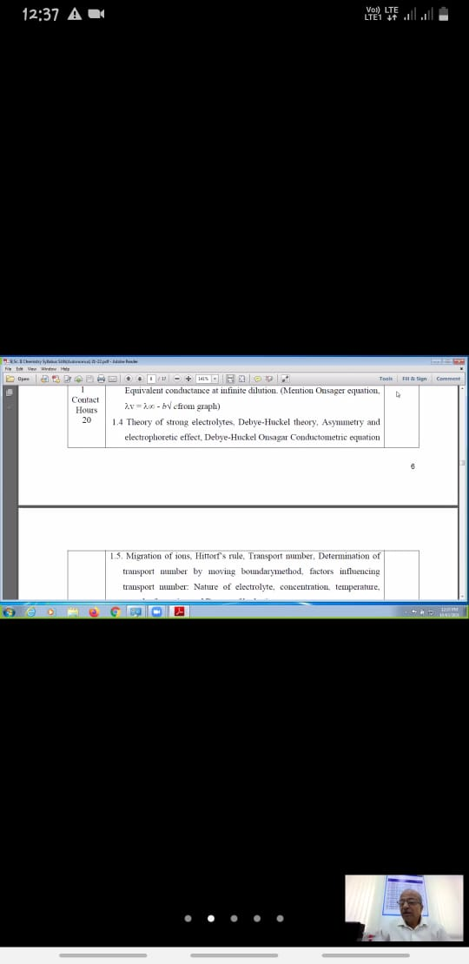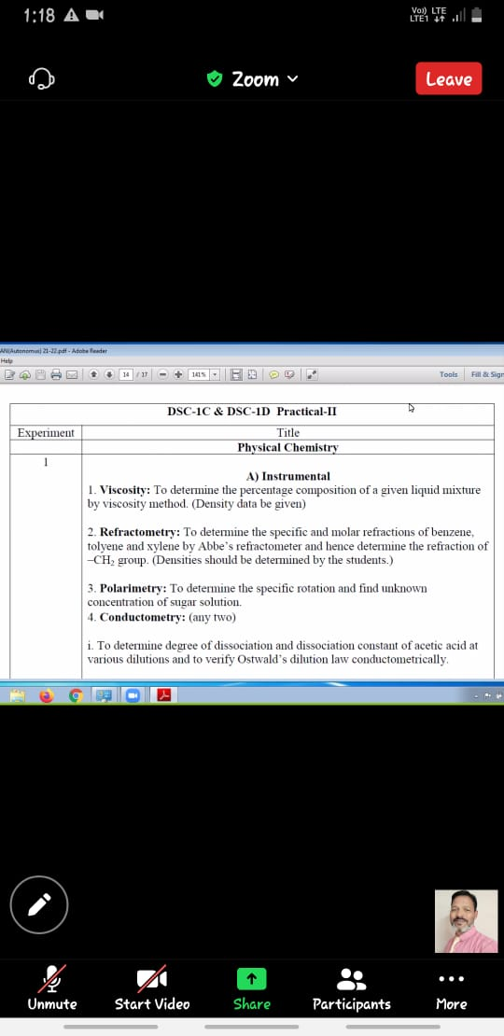

Chairman

Board of Studies Chemistry

Dr. U.M Mandle