SANGAMESHWAR COLLEGE (AUTONOMOUS), SOLAPUR
DEPARTMENT OF CHEMISTRY
Minutes of the 4th BOS (Chemistry) Meeting

A meeting of Board of Studies in Chemistry of Sangameshwar College, Solapur (Autonomous) was held on 8th March 2021 at 3.00 p.m. The said meeting was arranged on Zoom platform. The link for the online meeting was as under:
- https://us02web.zoom.us/j/89896526738?pwd=bmdLUWVEY1FXdTdCU0NEcktIbEtXUT09
Meeting ID: 89896526738 Passcode: BOS
Vice principal Dr. S.D. Gothe sir especially present for this meeting and present his welcome address.
Agenda of the meeting:
- To confirm the minutes of the previous meeting
- Discussion of third year draft syllabus
- Any other subject with the permission of chair

Following members were present for the meeting:
Sr. No. | Name of the Member | Designation
1 | Dr. U. M. Mandle | Chairman
2 | Dr.U.B. Chanshetti | (V.C.Nominee from the Parent University)
3 | Dr. G. S. Gokavi | Subject Expert outside the Parent University
4 | Dr. A. R. Patil | Subject Expert outside the Parent University
5 | Dr. Ravi Vibhute | Industry expert (…..)
6 | Dr. S. H. Gaikwad | PG Meritorious Alumnus
7 | Ms. K. D. Gaikwad | Member
8 | Dr. Ms. A. V. Diwate | Member
9 | Mr. S. D. Shaikh | Member
10 | Dr. D. S. Mhamane | Member
11 | Dr. P. B. Gorepatil | Member

Leave of absence was granted to the following member by the Chairman, Board of Studies:
- Dr. Ravi Vibhute
At the outset the chairman welcomed the members for attending the 3rd meeting of the board of studies. The chairman further expressed special thanks to Professor Dr. G.S. Gokavi (Subject experts from outside the Parent University) Kolhapur and Principal Dr.U.B. Chanshetti (V.C.Nomineefrom the Parent University) for sparing the time for their busy schedule to attend the meeting. After that the agenda items were taken up and the board decided/recommended as
Discussion as per Agenda:
- To confirm the minutes of 3rdmeeting of BOS B.Sc. II held on 28 May 2021.
The Board considered and confirmed the minutes of the 3rd meeting held on 28 May 2021 at 12.30 pm.
- To report the action taken, where necessary on the various decisions by the BOS in the 3rd meeting held on 28 May 2021.
The board noted the action taken where necessary on the various decisions taken in its3rd meeting held on21 May 2021. The Board also expressed its satisfaction on the action taken report on the various decisions taken in its3rd meeting held on 28 May 2021
- To suggest some points to change their sequence.
As per the suggestions of board of studies, The Board went through the syllabus of recommended topics in Physical chemistry and Analytical industrial physical chemistry (Paper- IX & XII).
- Any other item with the permission of the chair.
The discussions are made on introducing of SEC is well (B.Sc. III) planned syllabus. The Board suggested and agreed on the theory & practical syllabus.
After an in-depth discussion, the committeemembers unanimously approved the syllabus.
Finally, with the chair's permission, the meeting ended with vote of thanks by Prof. S. D. Shaikh.
Screenshot of Online Meeting (Attendance)
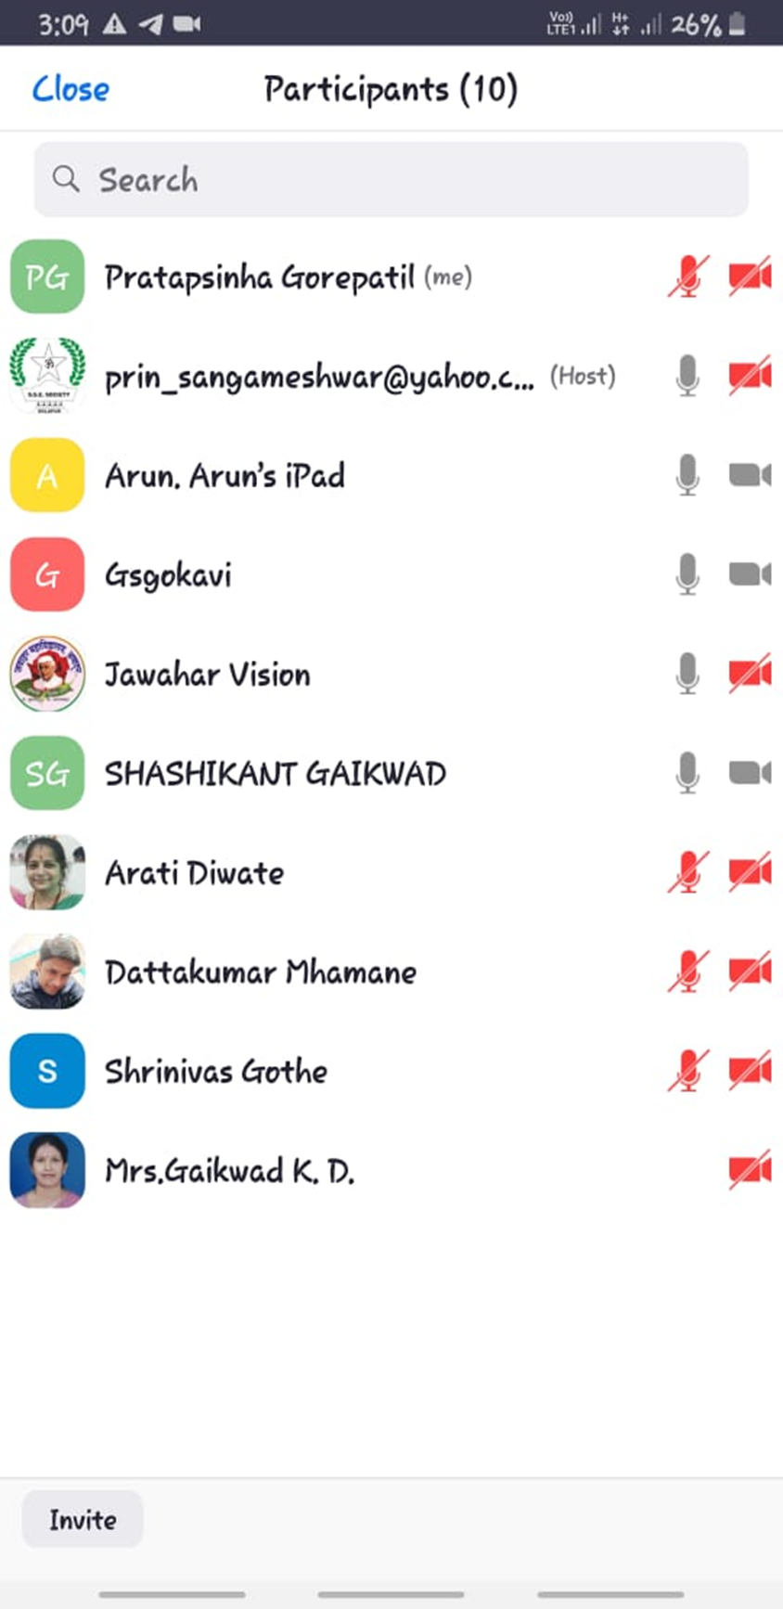

Chairman
Board of Studies Chemistry
Dr. U.M Mandle

