**SANGAMESHWAR COLLEGE (AUTONOMOUS), SOLAPUR**

**DEPARTMENT OF CHEMISTRY**

**Minutes of the 5th BOS (Chemistry) Meeting**

A meeting of Board of Studies in Chemistry of Sangameshwar College, Solapur (Autonomous) was held on 18 May 2022 at 4.00 p.m. The said meeting was arranged on Zoom platform. The link for the online meeting was as under:

* <https://us02web.zoom.us/j/83734066332?pwd=NHRDMUlNT09TaGxGcnRjK25kcUNFUT09>

Meeting ID: 837 3406 6332 Passcode: BOS

Vice principal Dr. S.D. Gothe sir especially present for this meeting and present his welcome address.

**Agenda of the meeting:**

1. To confirm the minutes of the previous meeting
2. Confirmation of third year draft syllabus
3. Any other subject with the permission of chair

Following members were present for the meeting:

|  |  |  |
| --- | --- | --- |
| **Sr. No.** | **Name of the Member** | **Designation** |
| 1 | Dr. U. M. Mandle | Chairman |
| 2 | Dr.U.B. Chanshetti | (V.C.Nominee from the Parent University) |
| 3 | Dr. G. S. Gokavi | Subject Expert outside the Parent University |
| 4 | Dr. A. R. Patil | Subject Expert outside the Parent University |
| 5 | Dr. Ravi Vibhute | Industry expert (…..) |
| 6 | Dr. S. H. Gaikwad | PG Meritorious Alumnus |
| 7 | Ms. K. D. Gaikwad | Member |
| 8 | Dr. Ms. A. V. Diwate | Member |
| 9 | Mr. S. D. Shaikh | Member |
| 10 | Dr. D. S. Mhamane | Member |
| 11 | Dr. P. B. Gorepatil | Member |

Leave of absence was granted to the following member by the Chairman, Board of Studies:

1. Dr. Ravi Vibhute

At the outset the chairman welcomed the members for attending the 3rd meeting of the board of studies. The chairman further expressed special thanks to Professor Dr. G.S. Gokavi (Subject experts from outside the Parent University) Kolhapur and Principal Dr.U.B. Chanshetti (V.C.Nomineefrom the Parent University) for sparing the time for their busy schedule to attend the meeting. After that the agenda items were taken up and the board decided/recommended as

**Discussion as per Agenda:**

1. To confirm the minutes of 4thmeeting of BOS B.Sc. III held on 8 March 2021.

The Board considered and confirmed the minutes of the 4th meeting held on 18 May 2022 at 4.0 pm.

1. To report the action taken, where necessary on the various decisions by the BOS in the 4thmeeting held on 18 March 2022.

The board noted the action taken where necessary on the various decisions taken in its meeting held on18 May 2022. The Board also expressed its satisfaction on the action taken report on the various decisions taken in its 4thmeeting held on 18 March 2022.

1. As per the suggestions of board of studies, The Board approved and confirms the syllabus.
2. Any other item with the permission of the chair.

The discussions are made on nature of question paper (B.Sc. III) planned syllabus. The Board approved and confirmed on the theory & practical syllabus.

After an in-depth discussion, the committeemembers unanimously approved the syllabus.

Finally, with the chair's permission, the meeting ended with vote of thanks by Prof. S. D. Shaikh.

**Screenshot of Online Meeting (Attendance)**

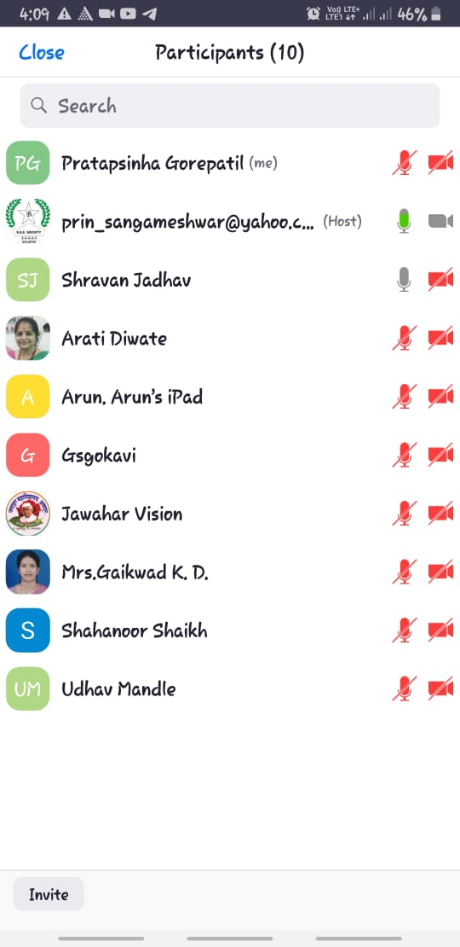

Chairman

Board of Studies Chemistry

Dr. U.M Mandle