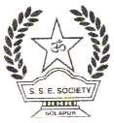

**SANGAMESHWAR COLLEGE (AUTONOMOUS), SOLAPUR**

**DEPARTMENT OF MATHEMATICS**

**MINUTES OF THE 2nd BOS**

A meeting of Board of Studies in Accountancy, Department of Mathematics , Sangameshwar College, Solapur (Autonomous) was held on Friday March 17, 2021 at 12.30 pm.

The said meeting was arranged online on Zoom platform.

**Link of Zoom Meeting**:

Topic: BOS 2nd Meeting  B.Sc-II Mathematics.

Time: Mar 17, 2021 12:30 PM India

Join Zoom Meeting

<https://us02web.zoom.us/j/89193566769?pwd=TlpKMVpDeFJrM0NzRlpBNnZkLzM0UT09>

Meeting ID: 891 9356 6769

Passcode: BOS2021

**Agenda of the meeting**

1. Confirmation of the minutes of the previous meeting.
2. To consider and approve the curriculum and syllabus for B.Sc-I & B.Com-I.
3. To consider and approve the panel of examiners for theory and practical exam to be held in Mar/April 2021.
4. To approve the titles and syllabi of B.Sc.II for academic session 2021-2022.
5. Discussion of second year draft syllabus.
6. Any other.

Following members were present for the meeting:

**Attendees:**

1. Prof. J. Prathapkumar (External Expert/other uni.)
2. Dr. Samket Tikare (External Expert/other uni.)
3. Dr. Mrs. Mashale J. D. (Parent Uni.)
4. Shri. Pawar P. V. (Expert From Industry)
5. Prof. Bhourgunde S. D. (Member Alumni)
6. Dr. Gade S. P. (Assistant Professor)
7. Mr. Dhone A.S. (Assistant Professor)

The Chairman Mr. Dhone A. S. introduced each member of the board and welcomed all members in the meeting. In his remarks, the chairman described the agenda items. Also our Vice-Prin Dr. S.D. Gothe guided the board and welcomed all members. He has given wishes for the great success/discussion. The chairman began the presentation on the previous meeting's minutes, which were

unanimously approved by all BOS members.

**During the Board of Studies meeting, the following points were discussed.**

**1. B.Sc. II Course Structure:**

The BOS Chairmen began her presentation by outlining the Course Structure and

the subjects covered in the B.Sc. Part II Programme. The structure was further

discussed and finalized by the members' board.

Table-3

Sangameshwar College, Solapur [Autonomous]

StructureofChoiceBasedCreditSystemforUndergraduateScienceProgramme B.Sc., B.Sc. (ECS), B.C.A. To be implemented from A.Y.2021-2022

|  |  |  |  |  |  |
| --- | --- | --- | --- | --- | --- |
| Semester | Course | | Teaching Scheme/week | | |
| Hours | Lectures | Credits |
| III |  |  |  |  |  |
| DSC-1C | Theory-I | 4.8 | 6 | 4 |
| Theory-II |
| Practical-II | 6.4 | 8 | 4 |
| DSC-2C | Theory-I | 4.8 | 6 | 4 |
| Theory-II |
| Practical-II | 6.4 | 8 | 4 |
| DSC-3C | Theory-I | 4.8 | 6 | 4 |
| Theory-II |
| Practical-II | 6.4 | 8 | 4 |
| SEC-1 | | 4.8 | 6 | 2 |
|  | **Total** | | **38.4** | **48** | **26** |
| IV | AECC-B  (Environmental Studies) | Theory-I | 3.2 | 4 | NC |
| DSC-1D | Theory-I | 4.8 | 6 | 4 |
| Theory-II |
| Practical-II | 6.4 | 8 | 2 |
| DSC-2D | Theory-I | 4.8 | 6 | 4 |
| Theory-II |
| Practical-II | 6.4 | 8 | 2 |
| DSC-3D | Theory-I | 4.8 | 6 | 4 |
| Theory-II |
| Practical-II | 6.4 | 8 | 2 |
| SEC-2 | | 4.8 | 6 | 2 |
| **Total** | | **38.4+3.2** | **48+4** | **26** |
| **Total Semester III and IV** | | | **76.8+3.2** | **96+4** | **52** |

Table-4

Sangameshwar College, Solapur [Autonomous]

Structure of Examination Mark Scheme of C.B.C.S. for Undergraduate Science Programme B.Sc., B.Sc.(ECS), B.C.A. To be implemented from A.Y.2021-2022

|  |  |  |  |  |  |  |
| --- | --- | --- | --- | --- | --- | --- |
| Semester | Course | | EXAMINATION | | | Credits |
| Marks | | |
| CA | SE | Total |
| III | DSC-1C | Theory-I | 15 | 35 | 50 | 2 |
| Theory-II | 15 | 35 | 50 | 2 |
| DSC-2C | Theory-I | 15 | 35 | 50 | 2 |
| Theory-II | 15 | 35 | 50 | 2 |
| DSC-3C | Theory-I | 15 | 35 | 50 | 2 |
| Theory-II | 15 | 35 | 50 | 2 |
| SEC-1 | Theory | 30 | 70 | 100 | 2 |
| **Total** | | **120** | **280** | **400** | **14** |
| IV | AECC-B  (Environmental Studies) | Theory-I | 15 | 35 | 50 | NC |
| DSC-1D | Theory-I | 15 | 35 | 50 | 2 |
| Theory-II | 15 | 35 | 50 | 2 |
| DSC-2D | Theory-I | 15 | 35 | 50 | 2 |
| Theory-II | 15 | 35 | 50 | 2 |
| DSC-3D | Theory-I | 15 | 35 | 50 | 2 |
| Theory-II | 15 | 35 | 50 | 2 |
| SEC-2 | Theory | 30 | 70 | 100 | 2 |
| DSC-1C& DSC-1D | Practical-I | 30 | 70 | 100 | 8 |
| DSC-2C& DSC-2D | Practical-I | 30 | 70 | 100 | 8 |
| DSC-3C& DSC-3D | Practical-I | 30 | 70 | 100 | 8 |
| **Total** | | **210+15** | **490+35** | **700+50** | **38** |
| **Total Semester III and IV** | | | **330+15** | **770+35** | **1100+50** | **52** |

CA: Continuous Assessment SEE: Semester End Examination

Note 03022021:

1. The above structure (Table-3and Table-4)is the draft structure for Sem-III and Sem-IV of the undergraduate programmes under science faculty.
2. For B.C.A., structure of examination may be different, in particular the practical exam.
3. **DSC: Discipline Specific Core Course**: Students can opt any Three subjects among the Four

Subjects offered at B.Sc.I. Out of Three Subjects offered One Subject will be the Core Subject.

1. **AECC: Ability Enhancement Core Course**: (Compulsory Course) Environmental Studies.

2. The members also discussed about addition of more applications and practical in Mathematics which helps the students in his/her career. He mentioned few branches viz

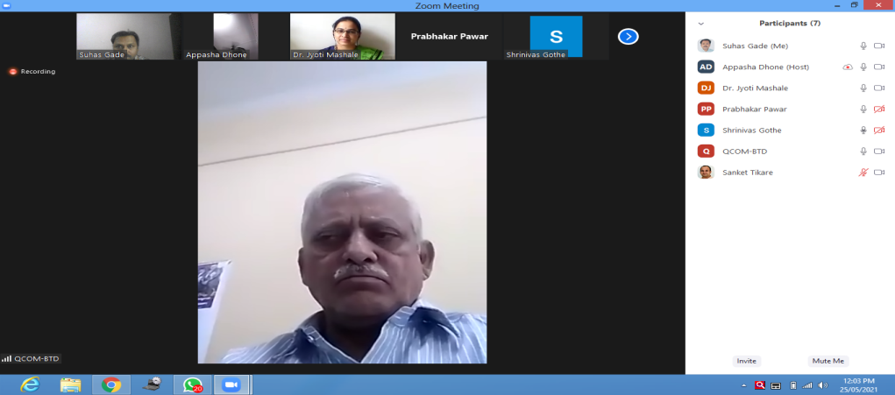

1. Applications of Differential equations
2. Applications of Numerical methods
3. Enhance the career aspects by the applications of theories
4. Enhance the problem solving skills
5. Modeling of physical problems

Shri Pawar P.V. sir focussed on practical’s in Mathematics.

The meeting ends with the vote of thanks by Dr. S. P. Gade.

**Chairman BOS In Mathematics**

**Dhone A S**