**I8SANGAMESHWAR COLLEGE (AUTONOMOUS), SOLAPUR**

**DEPARTMENT OF PHYSICS**

**Minutes of 2nd BOS Meeting held on 18th March 2021**

2nd Physics BOS Committee meeting was conducted through online mode on Zoom Platform on 18th March2021 at 2.00pm to approve and finalize BSc-I Draft syllabus to be implemented from June 2021-22.

**Agenda of the meeting:**

1. To confirm the minutes of the previous meeting conducted through email and telephonic conversations.
2. Discussion and suggestions from the committee members**.**
3. Finalization of BSc-I Draft Syllabus
4. Any other subject with the permission of chair

#### Link of meeting sent by WhatsApp and email to BOS members on 17th March 2021.

###### Principal Sangameshwar is inviting you to a scheduled Zoom meeting. Topic: Second BOS Meeting for, "Approve and Finalize BSc-I Syllabus"

**Time: March 18, 2021 02:00 PM Mumbai, Kolkata, New Delhi Join Zoom Meeting**

**https://us02web.zoom.us/j/86956532390?pwd=Z0RLaHBrNjkwbW05jBZRE9lU2Zz09**

**Meeting ID: 86956532390**

**Passcode: PhysicsBOS**

All the committee members were present for the meeting and exchanged their views and shared their valuable suggestions.

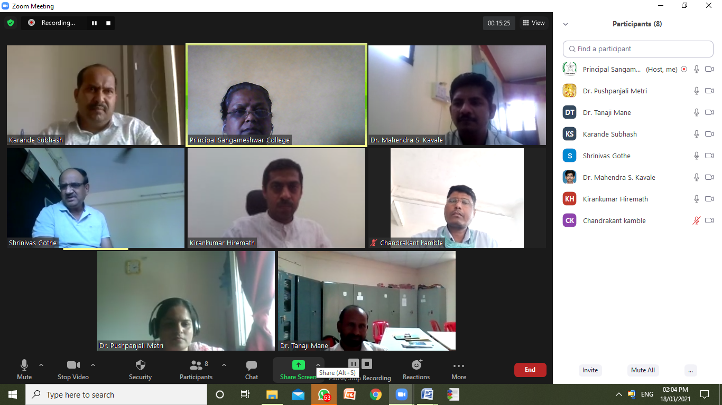

|  |
| --- |
| 1. Dr. T. R. Mane V.C. Nominee, PAH, Solapur University, Solapur 2. Dr. Amitabh Das Subject Expert, BARC, Mumbai 3. Dr. Niranjan Ramgir Subject Expert, BARC, Mumbai 4. Dr. K. R. Hiremath Alumini Representative, IIT Jodhpur 5. Mr. C. Kamble Industrialist Representative, OCSPL, Solapur 6. Dr. S. S. Karande Physics Dept. Sangameshwar College, Solapur 7. Dr. M. S. Kavale Physics Dept. Sangameshwar College, Solapur 8. Dr. P. G. Metri Physics Dept. Sangameshwar College, Solapur |

**Suggestions from BOS members:**

**Dr. Amitabh Das, BARC, Mumbai**

* Mechanics course be included on unit Gravitation and Fluid Dynamics.

(BSc-II syllabus)

* Computer Programming in C and/or Python could have been core course.
* (BSc-II syllabus) This suggestion is applicable at BSc-II level.

**Dr. K R Hiremath, IIT Jodhpur**

* Inclusion of topics like: Physics at nano-scale, Computational Physics.
* High Energy Physics
* Quantum Information and quantum computations
* Seminar (research paper based) course.
* Conduct such specialized courses using NPTEL courses, online/remote etc.
* (BSc-III syllabus) These suggestions are applicable at BSc-III level only.

With vote of Thanks by Dr. S. S. Karande the meeting was adjourned.

**18th March 2021 Mrs. S. S. Gavande**

**BOS Chairman**