**SANGAMESHWAR COLLEGE (AUTONOMOUS), SOLAPUR**

**Department of Physics**

#### Minutes of 3rd BOS Meeting held on 27th May 2021

3rd Physics BOS Committee meeting was conducted on 27th May 2021 at 4.00pm to approve and finalize BSc-II Draft syllabus to be implemented from June 2021-22.

The above meeting was conducted online on Zoom platform.

**Agenda of 3rd BOS Meeting:**

1. Confirmation of the minutes of the previous meeting (online discussion on Zoom Platform) held on 18th March 2022 at 4.00pm
2. Finalizing Second year syllabus
3. Any other item with the permission of the chair

The Zoom link of the meeting was:

#### Link of meeting sent by WhatsApp and email to BOS members on 25th May 2021 at 2.40pm

###### Principal Sangameshwar is inviting you to a scheduled Zoom meeting. Topic: Third BOS Meeting for, "Approval of BSc-II Syllabus"

**Time: May 27, 2021 03:00 PM Mumbai, Kolkata, New Delhi Join Zoom Meeting**

[**https://zoom.us/j/96467871739?pwd=ZXFkUUtlY3dCUi9lK1pzTXlCVXZmZz09**](https://zoom.us/j/96467871739?pwd=ZXFkUUtlY3dCUi9lK1pzTXlCVXZmZz09) **Meeting ID: 964 6787 1739**

**Passcode: PhysicsBOS**

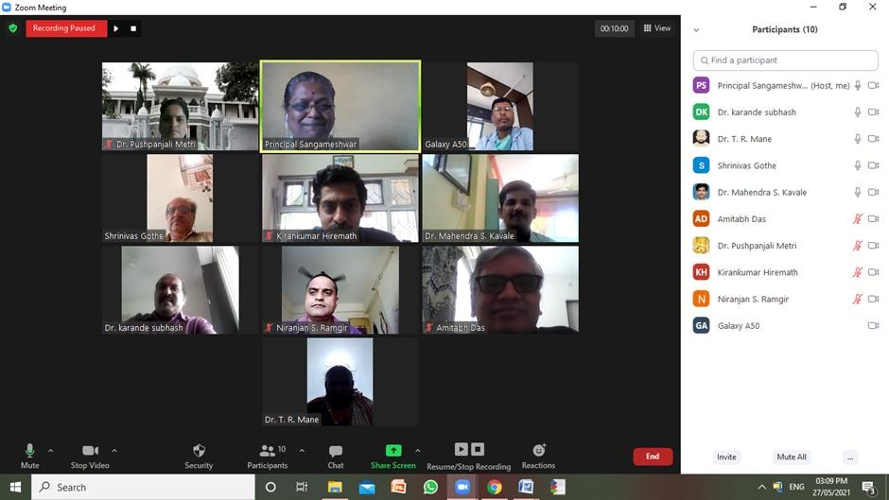

All the committee members were present for the online meeting:

* 1. Dr. T. R. Mane V.C. Nominee, PAH, Solapur University, Solapur
  2. Dr. Amitabh Das Subject Expert, BARC, Mumbai
  3. Dr. Niranjan Ramgir Subject Expert, BARC, Mumbai
  4. Dr. K. R. Hiremath Alumini Representative, IIT Jodhpur
  5. Mr. C. Kamble Industrialist Representative, OCSPL, Solapur
  6. Dr. S. S. Karande Physics Dept. Sangameshwar College, Solapur
  7. Dr. M. S. Kavale Physics Dept. Sangameshwar College, Solapur
  8. Dr. P. G. Metri Physics Dept. Sangameshwar College, Solapur

The following discussions were done in the meeting:

###### Confirmation of the minutes of the previous meeting held on 18th March 2021 Minutes of Meeting held on 18th Mar 2021:

Healthy and beneficial meeting discussions resulted in formation of Final BSc-II syllabus. The suggestions given by the BOS subject experts and VC nominee along with the other members were introduced in the syllabus. The suggestions given by them are summarised below.

**Suggestions from BOS members: (18th March 2021):**

**Dr. T. R. Mane, VC Nominee, P.A.H., Solapur University, Solapur:**

* There is difference in weight ages given to Practical Activity introduced and the Practical performed by the student. Each regular practical performed by the student is of 3 hours with

only 12 marks while; Practical Activity oral is given only during university examination and it is also given 12 marks. Students perform the practical which is similar to Practical Activity and gain no additional knowledge, information or skill as such in Practical Activity. Hence it is not necessary to conduct Practical Activity. This suggestion was strongly supported by Dr. Niranjan Ramgir Sir and Dr. Kiran Hiremath Sir also.

Suggestion was accepted and implemented

**Dr. Niranjan Ramgir, BARC, Mumbai:**

* Expectation from students is already achieved in performance of regular practical and hence Practical Activity is not needed.
* Conduct CA on Practical Activity instead of SSE.
* Conduct activities for students based on correlation of their real life situations with the subject knowledge gained through syllabus.

Suggestion was accepted and implemented and Practical Activity was included in CA examination instead of SEE examination.

**Dr. K R Hiremath, IIT Jodhpur:**

* + Sequence of reference books to be written as: Name of Author - Name of book – Edition

– Publisher.

The suggestion was accepted and implemented

* + Expose students to application of Physics to real life situation, so that the students will

practically see the situation through the theoretical part learnt by them in four walls of their classroom and apply it to explain the concept behind the real-life situation on the basis of what they have learnt. Dr. Niranjan Ramgir Sir too supported this suggestion.

* + Connect things from outside world with the syllabus taught in class. E.g. (1) Gio gives better Internet speed than BSNL as it uses optical fiber cable while BSNL uses copper cable. Similarly, Fluid Dynamics and Mechanics: Challenges faced by Submarines, challenges in designing high speed vehicles like specific shape of cars etc.

It was decided by the committee members that this suggestion will be implemented at BSc-III level.

* + For BSc-III students conduct Science competition, Project competition. Give credit to the Project equal to that of 1 certificate course.

It was decided by the committee members that this suggestion will be implemented at BSc-III level.

* Benchmark the syllabus with JAM syllabus to let students know their position in

comparison with the students of other old universities in competition to get admission through joint MSc-PhD entrance in IITs, centrally funded universities giving students good opportunity in going for higher education.

It was decided by the committee members that this suggestion will be implemented at BSc-III level.

**Dr. P. G. Metri, Assistant Professor, Sangameshwar College, Solapur:**

* Include Practical Activity but do not include in Continuous Examination (CA) instead of Semester End Examination (SSE). This suggestion was supported by Dr. Niranjan Ramgir Sir.

The JAM syllabus goes parallel to our College syllabus, it is nearly same. All these suggestions were included in the syllabus as follows:

**Dr. S. S. Karande, Assistant Professor, Sangameshwar College, Solapur: (Given by mail):**

* Include Practical Activity in the respective list of experiments given in each Practical Group accordingly instead of forming a separate group for the activity

1. Finalizing Second year syllabus

Healthy and beneficial meeting discussions resulted in approval of Final BSc-II Physics Syllabus to be implemented from June 2021-22. The suggestions given by the BOS subject experts and VC nominee along with the other members were introduced in the syllabus. There was about **25%** change done in BSc-II Syllabus by the BOS Committee members.

1. Any other item with the permission of the chair

***Suggestions from BOS members: (27th May 2021)**

Certain suggestions were given by the Board members as follows:

**Dr. Amitabh Das, BARC, Mumbai**

* + Sir suggested to organize a visit to BARC, Mumbai for BSc-II & BSc-III students with the permission of Collector.
  + Provide PCs in College for the students without the online accessories and Internet accessibility.
  + Write Tutorial instead of Problems at the end of each Chapter.

**Dr. K R Hiremath, IIT Jodhpur**

* + Conduct different types of online assignments: Upload videos and set questions on the uploaded video for the students to answer them ask them to summarize the video contents.
  + Upload Text books and Reference books and provide access to these books for the students.
  + Form a group of 3 to 4 students. Conduct Group activities so that the students learn to mix and interact with their group members/classmates.
  + Upload video lectures, video sessions etc.

The Fourth Meeting of the Academic Council was concluded after extending vote of thanks.

The suggestions were unanimously accepted by all the committee members.

With Vote of Thanks by Dr. M. S. Kavale the meeting was adjourned.

###### Date: 27th May, 2021 Chairman

**BOS in Physics**