**SANGAMESHWAR COLLEGE (AUTONOMOUS), SOLAPUR**

**Department of Physics**

**Minutes of 4th BOS Committee Online Meeting dated: 3rd March 2022**

4th Physics BOS Committee meeting was conducted on 3rd Mar 2022 at 4.00pm to discuss and finalize BSc-III Draft syllabus to be implemented from 2022-23.

**Agenda for 4th BOS**

1. Confirmation of the minutes of the previous meeting (email discussion) held on 2nd April 2020
2. Discussion of second year draft syllabus
3. Suggestions from BOS members
4. Comments from BOS members
5. Any other item with the permission of chair

**Physics BOS Zoom meeting schedule: Dt: 3rd March at 4.00pm**

prin_sangameshwar@yahoo.com is inviting you to a scheduled Zoom meeting.

Topic: prin_sangameshwar@yahoo.com's Zoom Meeting: Physics BOS Meeting

Time: Mar 3, 2022 04:00 PM Mumbai, Kolkata, New Delhi

Join Zoom Meeting

[**https://us02web.zoom.us/j/86377624794?pwd=V2tMdktYeXByaEY5VkFpQXRCVXRwQT09**](https://us02web.zoom.us/j/86377624794?pwd=V2tMdktYeXByaEY5VkFpQXRCVXRwQT09)

Meeting ID: 863 7762 4794

Passcode: sanphy

The following members were present for the online meeting:

1. Dr. Niranjan Ramgir Subject Expert, BARC, Mumbai
2. Dr. K. R. Hiremath Alumini Representative, IIT Jodhpur
3. Dr. T. R. Mane V.C. Nominee, PAH, Solapur University, Solapur
4. Mr. C. Kamble Industrialist Representative, OCSPL, Solapur
5. Dr. S. D. Gothe Vice-Principal, Sangameshwar College, Solapur
6. Dr. S. S. Karande Physics Dept. Sangameshwar College, Solapur
7. Dr. M. S. Kavale Physics Dept. Sangameshwar College, Solapur
8. Dr. P. G. Metri Physics Dept. Sangameshwar College, Solapur

Leave of absence was granted to the following member by the Chairman, Board of Studies:

1. **Dr. Amitabh Das Subject Expert, BARC, Mumbai**

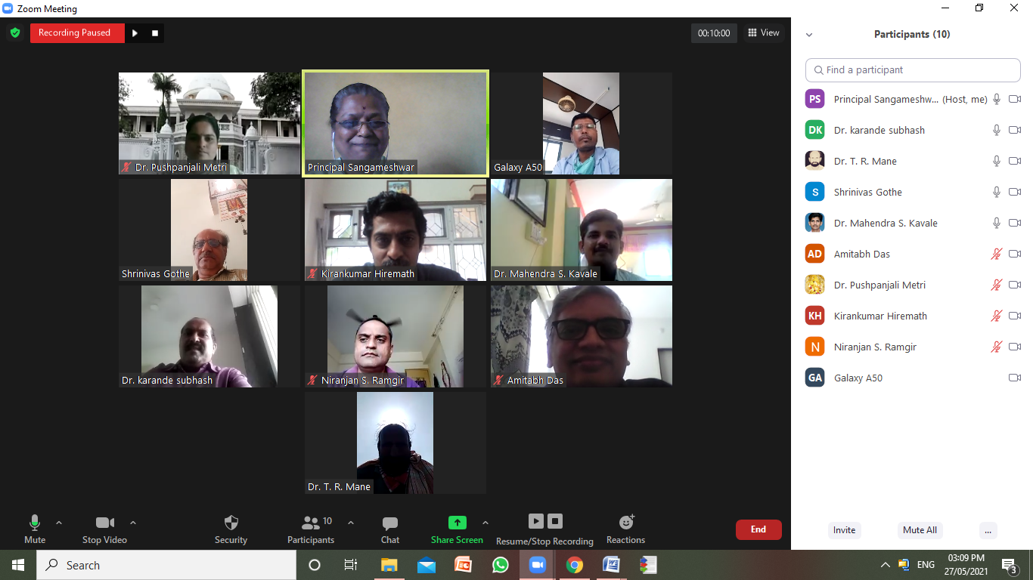

Healthy and useful meeting discussions was carried out on the Draft BSc-III syllabus. The suggestions given by the BOS subject experts are listed below.

**Suggestions from BOS members:**

**Dr. K R Hiremath, IIT Jodhpur**

* In evaluation of the student performance, the ‘outstanding grade’ should not be achieved by large number of students as this will indicate ‘very poor’ evaluation system. Also, if very small number of students achieve this grade, then this will indicate ‘very tough’ evaluation system. In both the cases, perfect evaluation of students will not take place. Hence, the ‘outstanding grade’ should be very carefully decided.
* Python software should not be included in ‘Electronics’ theory Paper. Instead, it should be continued in BSc-II SEC on C Programming and should be included in BSc-III to solve Mathematical Physics problems.
* Introduce basic understanding of Optoelectronics, wave guides, optical fibre.
* Train students for JAM entrance exams by giving them guidance, coaching, assignments so that they qualify for IIT entrance for M.Sc./ Integrated M.Sc. PhD
* Write the LO’s in short and not in elaborative way**.**
* The list of reference books should be 7-8 in number only to avoid confusion among students in using the reference book. Write the names of publisher & edition of the reference books**.**
* The syllabus is very heavy and exhaustive. Hence Mathematical and Statistical Physics should not be included**.**
* Include Name of the courses along with the course number in the mark list to clearly show the student’s excellence in the specific course**.**

**Dr. Amitabh Das, BARC, Mumbai**

* The adopted grading system at some point of time will switch to relative grading. So, decide the outstanding grade on the mean mass of students in the class. The number of students getting outstanding grade should not be high, this should be very seriously noted**.**
* Adopt NEP-2020 Policy for overall growth of the student more than academics**.**
* The institution should collect the status of students like: what they are doing after passing BSc-III? Are they employable? Do they go for HE? Or do they join Industry? The College should address students for their preparation for all the above options**.**

**Dr. Niranjan Ramgir, BARC, Mumbai**

* Incorporate Nanoparticle Toxicity, CMOS techniques in Material Science**.**
* Incorporate Clean room processes in Material Science**.**

With Vote of Thanks by Dr. M. S. Kavale the meeting was adjourned.

**3rd March 2022 Mrs. S. S. Gavande**

**BOS Chairman**