

**SANGAMESHWAR COLLEGE (AUTONOMOUS), SOLAPUR**

**Department of Physics**

**Minutes of 5th BOS Meeting held on 12th May 2022**

Fifth Physics BOS Committee meeting was conducted on 12th May 2022 at 4.00pm to approve and finalize Rectified BSc-III Draft syllabus to be implemented from August 2022-23.

The above meeting was conducted online on Zoom platform. The Zoom link of the meeting was:

**Link of meeting sent by WhatsApp and email to BOS members on 11th May 2022 at 10.00am**

**prin_sangameshwar@yahoo.com is inviting you to a scheduled Zoom meeting.**

**Topic: 5th Physics BOS Meeting for finalization of BSc-III Draft Syllabus (w.e.f., 2022-23)**

**Time: May 12, 2022 04:00 PM Mumbai, Kolkata, New Delhi**

**Join Zoom Meeting**

[**https://us02web.zoom.us/j/81184463970?pwd=a3NheGlsSkluQXVZZjIxNFl3OHBzUT09**](https://us02web.zoom.us/j/81184463970?pwd=a3NheGlsSkluQXVZZjIxNFl3OHBzUT09)

**Meeting ID: 811 8446 3970**

**Passcode: sanphy**

**Agenda for 5th BOS meeting**

**1)** Confirmation of the minutes of the previous meeting (online discussion on Zoom Platform) held on 3rd March 2022 at 4.00pm

**2)** Finalizing Third year syllabus

**3)** Any other item with the permission of the chair

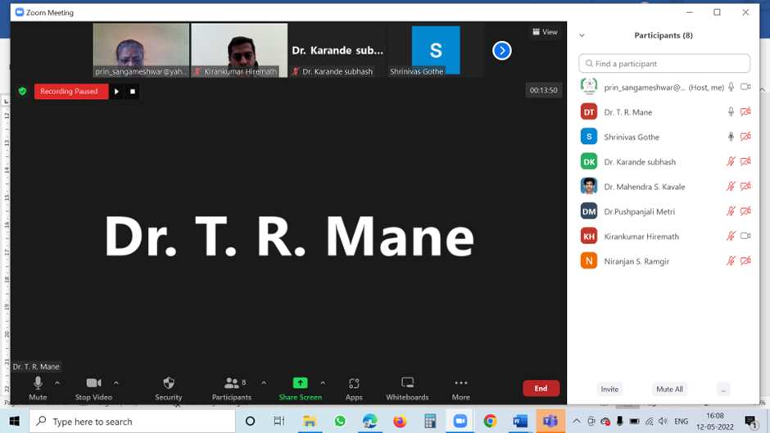

The following members were present for the online meeting:

1. Dr. T. R. Mane V.C. Nominee, PAH, Solapur University, Solapur
2. Dr. Niranjan Ramgir Subject Expert, BARC, Mumbai
3. Dr. K. R. Hiremath Alumini Representative, IIT Jodhpur
4. Dr. S. S. Karande Physics Dept. Sangameshwar College, Solapur
5. Dr. M. S. Kavale Physics Dept. Sangameshwar College, Solapur
6. Dr. P. G. Metri Physics Dept. Sangameshwar College, Solapur

Leave of absence was granted to the following member by the Chairman, Board of Studies:

1. **Dr. Amitabh Das Subject Expert, BARC, Mumbai**

1) **Confirmation of the minutes of the previous meeting held on 3rd March 2022**

**Minutes of Meeting held on 3rd Mar 2022:**

Healthy and beneficial meeting discussions resulted in formation of Final BSc-III syllabus. The suggestions given by the BOS subject experts and VC nominee along with the other members were introduced in the syllabus. The suggestions given by them are summarised below.

**Suggestions from BOS members: (3rd March 2022):**

**Dr. K R Hiremath, IIT Jodhpur**

* In evaluation of the student performance, the ‘outstanding grade’ should not be achieved by large number of students as this will indicate ‘very poor’ evaluation system. Also, if very small number of students achieve this grade, then this will indicate ‘very tough’ evaluation system. In both the cases, perfect evaluation of students will not take place. Hence, the ‘outstanding grade’ should be very carefully decided.

This suggestion was noted and decided unanimously by the committee members to be strictly implemented from evaluation of SEE conducted in Feb 2022.

* Python software should not be included in ‘Electronics’ theory Paper. Instead, it should be continued in BSc-II SEC on C Programming and should be included in BSc-III to solve Mathematical Physics problems.

Unit on Python was removed from Electronics Paper-XVI. An additional SEC-2 (Credits:02, Theory:15 hours, Lab:15 hours) was added in SEM-VI and has been designed on, ‘Python Programming”.

* Introduce basic understanding of Optoelectronics, wave guides, optical fibre.

Unit-6: Optoelectronics (06 hours) is included instead of Unit-6 on Python.

* Train students for JAM entrance exams by giving them guidance, coaching, assignments so that they qualify for IIT entrance for M.Sc./ Integrated M.Sc. PhD.

Already the staff members have started conducting lectures on, “Preparation for Entrance Examinations (M.Sc., Integrated M.Sc. PhD. of JAM, IITs, GATE)”.

* Write the LO’s in short and not in elaborative way.

Suggestion implemented in the present rectified syllabus.

* The list of reference books should be 7-8 in number only to avoid confusion among students in using the reference book. Write the names of publisher & edition of the reference books.

Suggestion is implemented in the present rectified syllabus.

* The syllabus is very heavy and exhaustive. Hence Mathematical and Statistical Physics should not be included.

This suggestion cannot be implemented as the structure, format and names of the papers given in the Parent University Syllabus cannot be changed as per instructions of PAHSUS.

* Include Name of the courses along with the course number in the mark list to clearly show the student’s excellence in the specific course.

This suggestion is forwarded to COE of our Examination Department.

**Dr. Amitabh Das, BARC, Mumbai**

* The adopted grading system at some point of time will switch to relative grading. So, decide the outstanding grade on the mean mass of students in the class. The number of students getting outstanding grade should not be high, this should be very seriously noted.

This suggestion was noted and decided unanimously by the committee members to be strictly implemented from evaluation of SEE conducted in Feb 2022.

* Adopt NEP-2020 Policy for overall growth of the student more than academics.

This suggestion was noted and decided unanimously by the committee members to be implemented from SEM-V of 2022-23.

* The institution should collect the status of students like: what they are doing after passing BSc-III? Are they employable? Do they go for HE? Or do they join Industry? The College should address students for their preparation for all the above options.

This suggestion was taken in to consideration and decided unanimously by the committee members to be implemented from this academic year 2021-22.

**Dr. Niranjan Ramgir, BARC, Mumbai**

* Incorporate Nanoparticle Toxicity, CMOS techniques in Material Science.

This suggestion cannot be implemented as these units are included in syllabus of PG like M.Sc. (Condensed Matter Physics).

* Incorporate Clean room processes in Material Science.

This suggestion cannot be implemented as these units are included in syllabus of PG like M.Sc. (Materials Science)

**2) Finalizing Third year syllabus**

Healthy and beneficial meeting discussions resulted in approval of Rectified Draft BSc-III Physics Syllabus to be implemented from June 2022-23. The suggestions given by the BOS subject experts and VC nominee along with the other members were introduced in the syllabus.

**3) Any other item with the permission of the chair**

* **Suggestions from BOS members: (27th May 2021)**

Certain suggestions were given by the Board members as follows:

**Dr. K R Hiremath, IIT Jodhpur**

* Compare the results of other Autonomous Colleges and Universities to benchmark the status of the performance of students of your college.

**Dr. Niranjan Ramgir, BARC, Mumbai**

* Employability of students depends on the percentage/class achieved by them in the third year. To increase the employability level of students, the students will have to acquire at least First class in the third-year examination. The difficulty level of examination should be decided such that; the First-class percentage of students should be more and the percentage of students above 90% should be less.

The suggestions were unanimously accepted by all the committee members.

With Vote of Thanks by Dr. P. G. Metri the meeting was adjourned.

**Date: 12th May, 2022 Chairman**

**BOS in Physics**