Shri Sangameshwar Education Society’s

Sangameshwar College (Autonomous), Solapur

Department of Political Science

**Board of Studies**

MINUTES OF THE 3rd Board of Studies-POLITICAL SCIENCE

A meeting of the Board of Studies (BoS) in Political Science was held on Saturday, 5 June 2021 at 4 pm. The meeting was conducted online through Zoom platform.

Link of Zoom Meeting:

https://us04web.zoom.us/j/77137633140?pwd=b3poVHBUKzQvQWVsalRudUk3NmZvZz09

Meeting ID: 771 3763 3140

Passcode: 6x52iL

Agenda of the meeting

1) Confirmation of the minutes of the previous meeting

2) Finalization of second year syllabus

3) Any other item with the permission of chair

The following BoS members were present for the meeting:

|  |  |  |
| --- | --- | --- |
| 1 | Dr. Ms. S.D. Sarwade | Member |
| 2 | Dr. S.K. Shinde (V.C. Nominee from the Parent University) | Member |
| 3 | Mr. P.M. Pawar (Subject experts from outside the Parent University) | Member |
| 5 | Mr. M.R. Shirapurkar (Representative from Industry/Corporate sector/allied area) | Member |
| 6 | Ms. T.R.Ranshringare (Postgraduate meritorious alumnus) | Member |
| 7 | Mr. R.P. Buwa | Chairman |

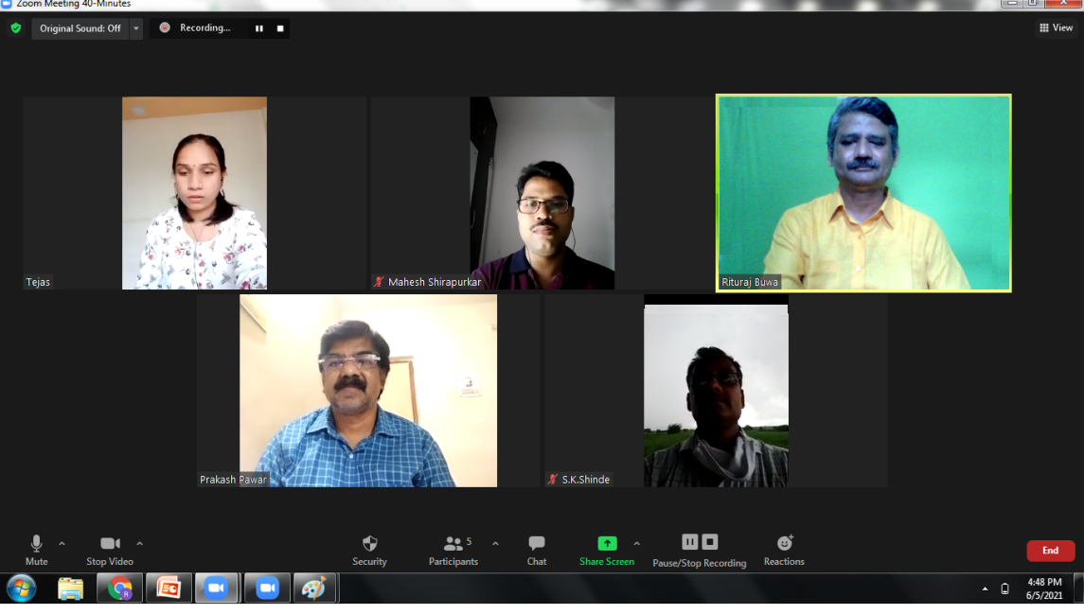

The Chairman Ruturaj Buwa welcomed the members BOS and presented the agenda of the meeting. The leave of absence was granted to Dr. Sangram More as per his communication. Dr. More had a meeting with government officer at the time of BoS Meeting.

A detailed discussion was held on each item on agenda.

1) Confirmation of the minutes of the previous meeting

a. Structure of BA II and MA II Political Science

b. BA II Papers (3) and MA II Compulsory Papers

c. Political Science Eligibility for Admission to M.A.

The structure of BA II and MA II (Political Science) was unanimously approved by the members. The change in the eligibility rules was also approved by all the members.

2) Finalization of second year syllabus

The members approved the syllabus of BA II and discussed the details of MA II syllabus.

Mr. Prakash Pawar asked to drop Kautilya from the course of Modern Indian Political Thought, as Kautilya belonged to the ancient times. Dr. Mahesh Shirapurkar suggested to either drop Kautilya or to change the name of the Course to Indian Political Thought.

Dr. Mahesh Shirapurkar suggested adding New Public Management in the course of Public Administration.

It is unanimously decided to finalize the name of India’s Foreign Policy instead of India and the World. Dr. Shirapurkar, Mr. Pawar, Dr. Shinde suggested to carefully design the course about social media and democracy and provide the study material to the students.

All the members agreed to give their suggestions and consent for the draft syllabus of MA II by email.

The meeting concluded with the vote of thanks by Ruturaj Buwa.

_________________