Shri Sangameshwar Education Society’s

Sangameshwar College (Autonomous), Solapur

Department of Political Science

**Board of Studies**

MINUTES OF THE 4th Board of Studies-POLITICAL SCIENCE

A meeting of the Board of Studies (BoS) in Political Science was held on Monday, 14 March 2022 at 4 pm. The meeting was conducted online through Zoom platform.

Link of Zoom Meeting: https://us02web.zoom.us/j/82480209443?pwd=bC8zaWxzSHZhSmE5RkVSa0MxMFhZZz09

Meeting ID: 824 8020 9443

Passcode: 874902

Agenda of the meeting

1. Confirmation of the minutes of Last meeting
2. Discussion of UG third year draft syllabus
3. Any other item with the permission of the chair

The following BoS members were present for the meeting:

|  |  |  |
| --- | --- | --- |
| 1 | Dr. Sangram More  (Subject experts from outside the Parent University) | Member |
| 2 | Dr. S.K. Shinde (V.C. Nominee from the Parent University) | Member |
| 3 | Dr. M.R. Shirapurkar (Representative from Industry/Corporate sector/allied area) | Member |
| 4 | Dr. Ms. S.D. Sarwade | Member |
| 5 | Mr. R.P. Buwa | Chairman |

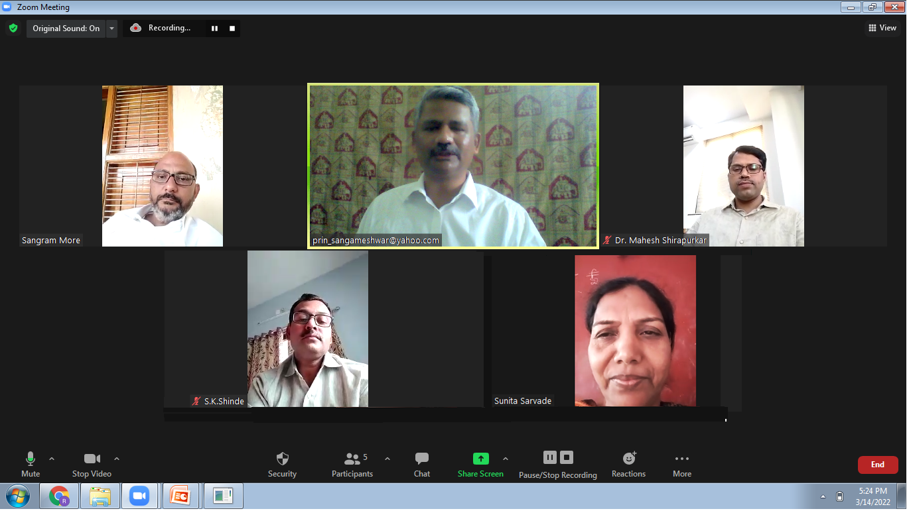

The leave of absence was granted to Prakas Pawar and Tejaswita Ranshringare as per their request.

A detailed discussion was held on each item on agenda

1) Confirmation of the minutes of Last meeting

a. Finalization of second year syllabus

The syllabus of BA II and MA II (Political Science) was unanimously approved by the members.

2) Discussion on UG third year draft syllabus

Overview of the structure was introduced by the Chairman.

Dr. Sangram More suggested including left parties in the syllabus.

Dr. Mahesh Shirapurkar suggested adding Afghanistan as the neighbouring country of India in International Relations.

3) Any other item with the permission of the Chair.

Dr. Sangram More asked for organization of lectures of BoS members (online) in the near future.

Dr. Shirapurkar and Dr. Sangram More suggested carefully designing the Skill Enhancement Course about Political Journalism and insisted to provide the study material to the students.

The members approved the draft syllabus of BA III with some suggestions and modifications.

All the members agreed to convey (by mail) their suggestions and consent for the draft syllabus of BA III before the next Board of Studies meeting.

The meeting concluded with the vote of thanks by Ruturaj Buwa.

_________________