Shri Sangameshwar Education Society’s

Sangameshwar College (Autonomous), Solapur

Department of Political Science

**Board of Studies**

MINUTES OF THE 5th Board of Studies-POLITICAL SCIENCE

A meeting of the Board of Studies (BoS) in Political Science was held on Saturday, 21 May 2022 at 4 pm. The meeting was conducted online through Zoom platform.

Link of Zoom Meeting:

https://us02web.zoom.us/j/85971565412?pwd=VFdhWjRndURBcDNmZUlHc1JsbWJNUT09

Meeting ID: 859 7156 5412

Passcode: 839219

Agenda of the meeting

1) Confirmation of the minutes of the previous meeting

2) Finalization of third year syllabus

3) Any other item with the permission of chair

The following BoS members were present for the meeting:

|  |  |  |
| --- | --- | --- |
| 1 | Dr. P.M. Pawar (Subject experts from outside the Parent University)Dr. Ms. | Member |
| 2 | Dr. M.R. Shirapurkar (Representative from Industry/Corporate sector/allied area) | Member |
| 3 | S.D. Sarwade | Member |
| 4 | Dr. V.G. Kore | Member |
| 5 | Dr. R.P. Buwa | Chairman |

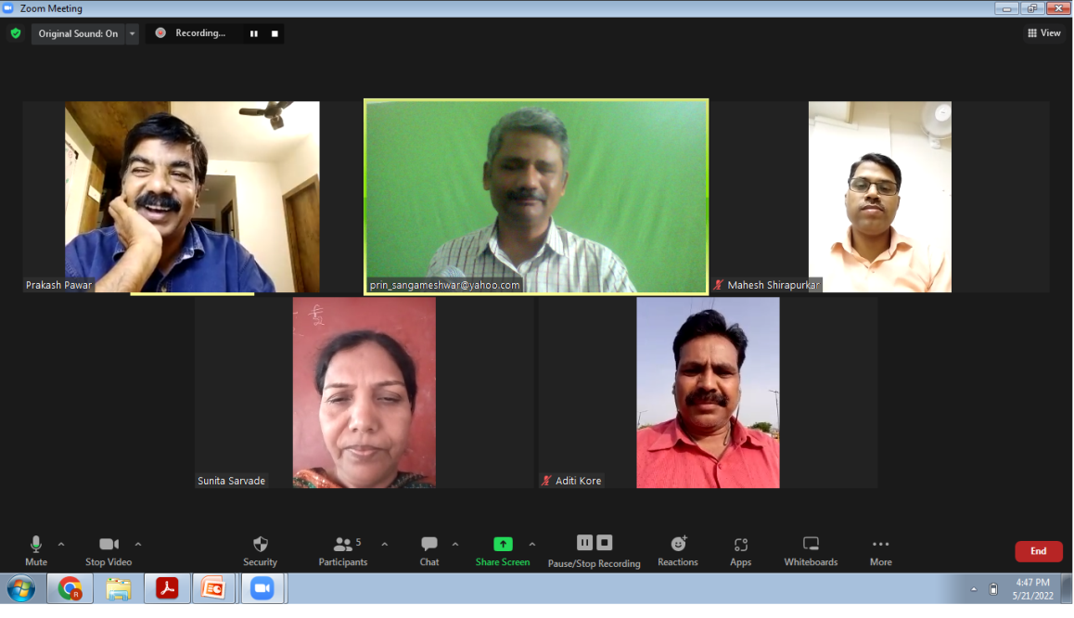

The leave of absence was granted to Dr. Sangram More, Dr. Sushilkumar Shinde and Tejaswita Ranshringare.

Dr. Prakash Pawar suggested including various political parties in the paper of Government and Politics of Maharashtra.

Dr. V.G. Kore asked to relate the paper of Comparative Politics with India.

Syllabus of third year BA was approved unanimously.

The meeting concluded with the vote of thanks by Ruturaj Buwa.

_________________